

Tuesday 15 October 2019 13:56, UK

**UK suspends arms sales to Turkey for items that might be used in Syria**

Foreign Secretary Dominic Raab tells MPs that export licenses will be halted following Turkey's "reckless" action.

**The UK has suspended new sales of**

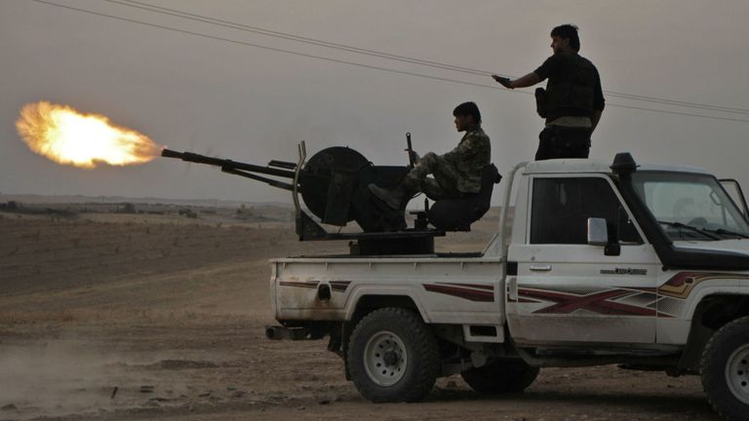

[Image: Turkey has launched a military offensive in northeast Syria](https://twitter.com/intent/tweet?text=UK%20suspends%20arms%20sales%20to%20Turkey%20for%20items%20that%20might%20be%20used%20in%20Syria&url=https%3A%2F%2Fnews.sky.com%2Fstory%2Fuk-suspends-arms-export-licences-to-turkey-over-military-offensive-in-syria-11836210" \o "Share on Twitter" \t "_blank)

**arms to Turkey for items that might**

**be used in the country's military**

**offensive in Syria.**

Foreign Secretary Dominic Raab told

MPs on Tuesday: "The UK government

takes its arm export control

responsibilities very seriously and, in

this case, of course, we will keep our

defense exports to Turkey under very careful and continual review.

"No further export licenses to Turkey for items that might be used in military operations in Syria will be granted while we conduct that review."

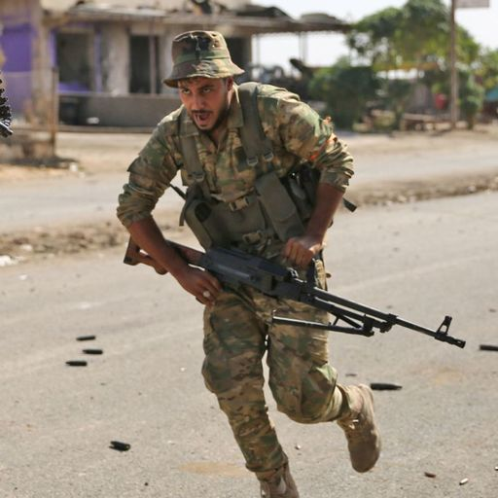Turkey's military incursion in Syria entered its seventh day on Tuesday, with reports of heavy bombardment of Syrian Kurdish positions near a town in northeast Syria.

Turkey's operation aims to remove Syrian Kurdish forces - which Ankara regards as terrorists and links to a decades-old insurgency in the country - from its border. President Recep Tayyip Erdoğan has pledged to continue with Turkey's military operations, despite international condemnation.

Mr. Raab told the House of Commons: "With close partners, we must at times be candid and clear.

"This is not the action we expected from an ally. It is reckless, it is counter-productive"

The foreign secretary added Turkey's offensive "plays straight into the hands of Russia" and the Syrian regime, led by Bashar al-Assad.

<https://news.sky.com/story/uk-suspends-arms-export-licences-to-turkey-over-military-offensive-in-syria-11836210>